Suction cup option for lifting the pyramid:

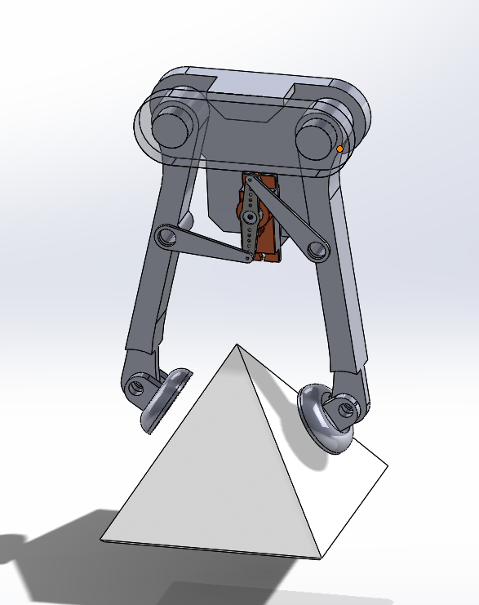

Geartrain for amplifying clamping force. Arm links attached to holes in output gear.

